- Select the wrench
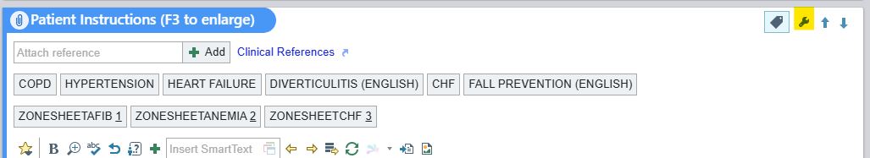

- Add smartphrase, caption it, and select accept
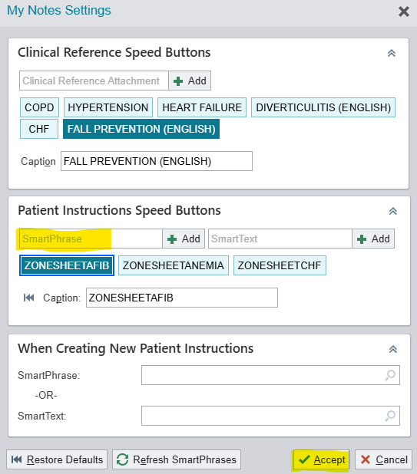

- Click on a speed button to add a zone sheet to your patient instructions
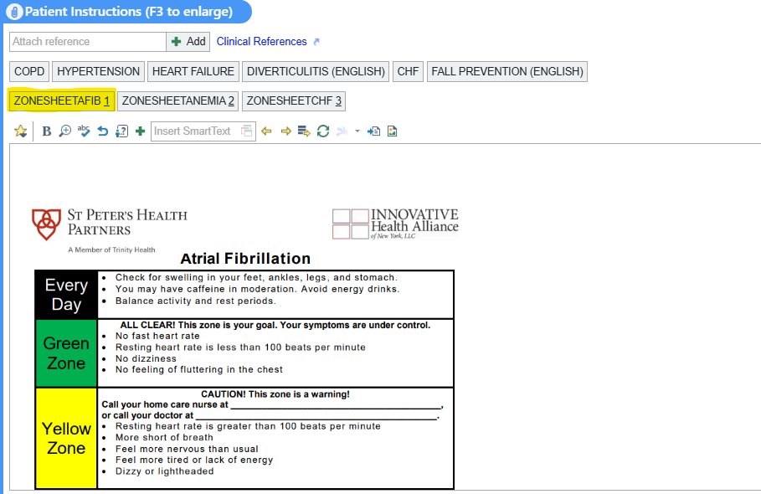

Created by: Kelsey White RN, BSN

