**General Steps for All Members**

1. Confirm HARP Enrolled status in ePaces, as evidenced by the presence of an H1 code.

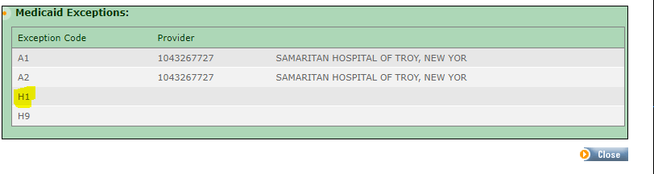

1. Discuss with the Member the benefits of HCBS and CORE services available via their HARP Enrollment. Consult the **HCBS CORE Resource Tool** document for how to relate Member goals to HCBS or CORE services.
2. Once the Member identifies what services they would like to pursue begin steps to link them to the services. Please note there are different pathways to access services depending on if they are HCBS or CORE services. A Member may choose services from both the HCBS and CORE Services array.

|  |  |
| --- | --- |
| **Home and Community Based Services (HCBS)** | **Community Oriented Recovery and Empowerment (CORE) Services** |
| Habilitation | Psychosocial Rehab (PSR) |
| Education Support Services | Empowerment Services – Peer Supports |
| Pre-Vocational Services | Family Support and Training |
| Transitional Employment | Community Psychiatric Support and Treatment (CPST) |
| Intensive Supported Employment Support |
| Ongoing Supported Employment Support |  |
| Non-Medical Transportation* |  |

*Members receiving CORE services can also access Non-Medical Transportation Services, however the HCBS Services Pathway outlined on pages 2 and 3 must be followed to obtain Non-Medical Transportation.

1. If the Member does not wish to pursue any services under HARP, reflect this declination in your note documentation and complete the *HCBS / CORE Services Declined* General Assessment in CareManager.

**CORE Services Pathway**

1. If the Member chooses services under the CORE menu of services, identify which CORE Service providers offer that service.

See the most up to date list by county here: <https://omh.ny.gov/omhweb/bho/core/providers/>

1. Once providers are selected, complete the **HCBS CORE Referral Form** and submit it to the agency contact.
2. If possible, include the **CORE LPHA Recommendation Form** with the referral. If you cannot include the recommendation form, please indicate that on page 2 of the HCBS CORE Referral Form.

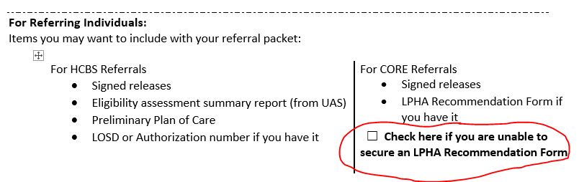

1. Upload a copy of the referral to CareManager and complete the *CORE Referral Submitted* General Assessment in CareManager.

**HCBS Services Pathway**

1. If the Member chooses services under the HCBS menu of services, complete the Eligibility Assessment to determine if the Member is Tier 1 or Tier 2 eligible. This dictates what services can be pursued under HCBS.

|  |  |
| --- | --- |
| **Tier I** | **Tier 2** |
| Education Support Services | Education Support Services |
| Pre-Vocational Services | Pre-Vocational Services |
| Transitional Employment | Transitional Employment |
| Intensive Supported Employment Support | Intensive Supported Employment Support |
| Ongoing Supported Employment Support | Ongoing Supported Employment Support |
| Non-Medical Transportation | Non-Medical Transportation |
|  | Habilitation |

1. Upon completion of the Eligibility Assessment in the UAS, complete the *Eligibility Assessment Completed* General Assessment in CareManager and upload the documents from the UAS regarding HCBS eligibility.
2. If after the Eligibility Assessment is completed, the Member chooses to no longer pursue any HCBS services, document this declination in your notes and complete the *HCBS Decline Post Assessment* General Assessment in CareManager and do not complete the remainder of the steps in this document.
3. Complete the **Preliminary POC LOSD-R** (Level of Service Determination Request) with the Member and submit it to the MCO for approval for HCBS services. Upload the document in CareManager and complete the *LOSD-R / PPOC Submitted to MCO* General Assessment in CareManager.
4. The MCO will reply back with their Level of Service Determination (LOSD) approval and a list of available HCBS providers, ideally within 14 days of submission of the LOSD-R.
5. Upload the LOSD from the MCO and work with the Member on selecting providers and submitting the **HCBS CORE Referral Form** to begin services.
6. Once engaged with the HCBS providers, the Full Plan of Care (**HCBS POC Template**) should be completed with the Member and submitted to the MCO. Note that HCBS service providers will need to provide some information for the completion of this document.
7. Once finalized and sent, upload a copy of the Full Plan of Care to CareManager and complete the *HARP Plan of Care Submitted to the MCO* General Assessment in CareManager.
8. The Eligibility Assessment will need to be completed annually based on time of initial assessment for those Members engaged in HCBS. Upon annual completion of the Eligibility Assessment, complete the *Eligibility Assessment Completed* General Assessment in CareManager. If there are no changes to the services the Member wishes to pursue, no further action is needed. If new services are identified, go back to step 4 and repeat.

**Once Members are engaged in HCBS or CORE services, please help to keep them engaged in those services and remember to add those services providers to the Care Team for ongoing collaboration.