|  |  |
| --- | --- |
|  | **Effective Date:** 2-2016 |
| **Title: Dermal Puncture Capillary Collection by Finger stick** | |
| **Author: Kimberley DeNovio Phlebotomy Manager SPHP Signature:** | |
| **Applies to:**  **The following SPHP Component Corporations:**  **St. Peter’s Hospital – Medical Director: Lisle Eaton M.D. ________________________________**  **Albany Memorial Hospital – Medical Director: Lisle Eaton M.D. __________________________**    **Samaritan Hospital – Medical Director: Dalia Eldeiry M.D. ______________________________**  **St. Mary’s Hospital – Medical Director: Dalia Eldeiry M.D. ______________________________**  **St. Peter’s Health Partners Medical Associates – Medical Director: Thomas Lawrence M.D.**    **______________________________** | |

Supersedes: DocuShare/Laboratory/Laboratory Resource Manual/Blood Collection/Blood Collection by Finger Stick – Capillary 7-14

Location: DocuShare/Laboratory/Laboratory Resource Manual/Blood Collection/Blood Dermal Puncture Capillary Collection by Finger stick

**PRINCIPLE:**

Dermal puncture is a method used when venipuncture cannot be performed or may be the option of choice for some point-of-care testing. A dermal puncture maybe performed due to many reasons:

It is an alternate method for obtaining a blood sample from an adult or child over 1year of age, when only a small volume is needed and/or venipuncture is not possible. Fingers of an infant less than 1 year of age may not contain enough tissue to prevent contact with the bone and is not suitable for use in this case the hell is the site of choice. (Refer to heel stick procedure)

In adult patients it's an alternative for patient's receiving chemotherapy, burned or serverly scarred and when there is no venous access.

***Specimen Collection:***

***Patient Perpetration*:**

1. The non-dominant hand is preferred, with the hand positioned below the heart.
2. The third and fourth fingers on the plantar side are the sites of choice for finger puncture.
3. The tip and sides of the finger contain only half tissue mass of the central area the possibility of bone injury is increased in these areas.

**EQUIPMENT AND MATERIALS:**

* Specimen collection tubes and/or microtainers and/or test strips, etc.

(will vary depending on ordered tests)

- 2 x 2 sterile gauze pads - clean gloves

- 70 % isopropyl alcohol preps - sharps container

- Automatic lancet device - biohazard specimen bag

- Band aid or paper tape

.

**TEST PROCEDURE:**

1. Identify self to patient and/or guardian and explain procedure. ID patient in accordance with the positive ID policy using the name and DOB and confirm with the hospital ID band (inpatients).
2. Confirm patient identity by asking for full name and date of birth.
3. Confirm test order and specimen requirements before beginning procedure.
4. Assemble necessary materials.
5. Patient must be lying down or seated during entire procedure.
6. Instruct patient to let arm hang in a downward position for at least 30 seconds.
7. Wash hands and put on clean gloves.
8. Choose either the middle or 3rd finger of non-dominant hand and cleanse the fingertip with 70% alcohol prep. Allow to air dry.



1. Using a sterile automatic lancet device, puncture skin just off center of the finger pad. The puncture should be made across the ridges of the fingerprint to enhance droplet formation.
2. Wipe away first drop of blood with sterile gauze to eliminate tissue juice contamination.
3. Gently massage the patient’s finger to force the blood toward the tip. Then, gently apply pressure to the sides of the finger. (Avoid excessive pressure.)

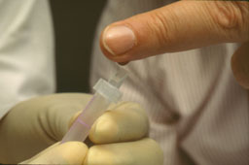

1. Apply drops of blood into or onto the appropriate containers as required by ordered tests. Tubes containing anticoagulant should be capped and then gently inverted and/or tapped to mix properly. Do NOT shake violently.
2. When collection is finished, have patient hold sterile gauze onto puncture site until bleeding stops.
3. Label each container with the patient’s name and DOB. Record date, time and phlebotomist’s initials on requisition slip.
4. Check the condition of the patient. Bandage finger if necessary, and thank the patient.
5. Place specimen in biohazard specimen bag.
6. Dispose of contaminated materials in appropriate containers. Lancets must be placed in a sharps container.
7. Remove gloves and wash hands.
8. Deliver labeled specimens to laboratory in a timely manner.

**LIMITATIONS OF PROCEDURE:**

1. Blood Cultures must NOT be collected by finger stick or heel stick.
2. If bubbles are present when collection capillary blood in a micro collection tube. Bubbles in the tube can cause inadequate sample volume or exposure to air in the case of blood gases.

1. Specimens MUST be discarded and re-collected if: improperly labeled, unlabelled, Hemolyzed, clotted (in anticoagulant) AND/OR exceeds time requirements
2. Order of draw for the mircrocontainers: lavender then yellow/amber/red tubes.

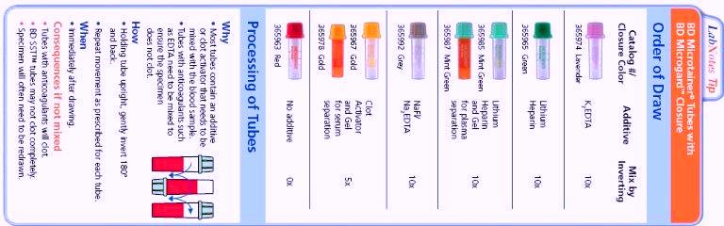

**REFERENCES:**

1. M.D. Anderson Hospital, Department of Clinical Chemistry and Laboratory

Medicine, Venipuncture Manual. 1974.

1. Microtainer Brand Tubes, Becton Dickinson, June 1997.
2. LSUMC, Clinical Laboratory Policy and Procedure Manual, [www.sh.lsuhsc.edu](http://www.sh.lsuhsc.edu),

Dec. 2005.

1. Clinical and Laboratory Standards Institute, Vol. 24, No. 21, June 20 2004.

Phlebotomy workbook for the multiskilled Healthcare Professional, Susan King Strasinger; Marjorie A. DoLorenzo Copyright 1996