

  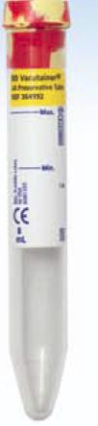

Grey Tube Yellow Tube Tiger Tube

|  |  |  |  |  |  |  |  |
| --- | --- | --- | --- | --- | --- | --- | --- |
| TEST | # of Tubes |  | Test | # of Tubes |  | Test | # of Tubes |
| Urine Culture | 1-Grey |  | Urine HCG | 1-Yellow |  | Routine Urinalysis | 1-Tiger |
|  |  |  | Urine Drug Screen | 1-Yellow |  | Urine Cytology | 1-Tiger |
|  |  |  | Urine Drug Screen w/conf | 2-yellow |  |  |  |
|  |  |  | Urine Electrolytes | 1-yellow |  |  |  |
|  |  |  | Urine Electrophoresis | 2-yellow |  |  |  |
|  |  |  | Other Urine Chemistry test | 1-Yellow |  |  |  |
|  |  |  | Urine Microalbumin | 1-Yellow |  |  |  |
|  |  |  | Legionella Urinary Antigen | 1-Yellow |  |  |  |
|  |  |  | Urine for Chlamydia/GC RNA/TMA | 1-Yellow |  |  |  |
|  |  |  | Urine Ureaplasma/ Mycoplasma | 3-Yellow |  |  |  |
|  |  |  |  |  |  |  |  |

12/2016