Blood Culture Procedure

Author: Kimberley DeNovio
Medical Director:
Reviewed by: Kimberley DeNovio  POCT Manager SPHP | 11-2-2015

Supersedes:
File name:

PURPOSE:
Septicemia (sepsis) occurs in approximately 200,000 patients each year, and between 30-50% of those patients die. Because the consequences of septicemia are so serious, rapid and accurate diagnosis of this disorder is critical.
The blood culture is the best diagnostic tool for detecting septicemia, and it’s absolutely imperative that the blood specimen be collected properly to provide clinically valuable results.

POLICY STATEMENTS:
If recommended best practices are not adhered to during blood culture collection, the resulting negative impact for patients can include:
- ~unnecessary antibiotic treatment

- ~increased length of stay

- ~increased health care costs.
It may also lead to an increase the number of hospital acquired central line associated blood stream infections (CLABSI) since the results are difficult to distinguish from a true CLABSI

SCOPE OF AUTHORITY / COMPETENCY: MD, RN, LPN,PCT, and phlebotomist

DEFINITIONS: Blood cultures are a critical test in the clinical diagnosis of infection

PROCEDURE:
EQUIPMENT:
Clean Gloves
Tourniquet Blood Culture bottles
Tape 2x2 Gauze Pads
Patient Labels Specimen Bags

Blood Culture requirements per set:
2 bottles: 1- aerobic & 1- anaerobic bottle
1- Blood culture vacutainer holder
Alcohol swab and chlorhexidine swab
1 -winged infusion needle
***Always draw the aerobic bottle before the anaerobic bottle***

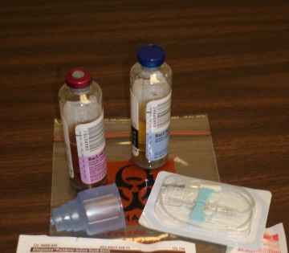

STEPS:
1. Verify Blood Culture orders.(if order is blood cultures x2 then this will require 2 separate venipunctures.)

2. If other bloods are ordered verify blood tubes needed, specific handling conditions and test procedures, if applicable.

3. Positively identify the patient using the name and date of birth and explain procedure to patient.

4. Wash hands.

5. Apply clean gloves.

6 Assemble all equipment needed to perform blood drawing procedure. (Assemble the winged infusion needle into the blood culture vacutainer holder)

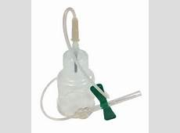
7.Prepare the bottles by removing the plastic protective cap from the top of the bottles. Disinfect tops of two bottles with alcohol swab, allow to air dry.

8. Position patient for comfort, provide privacy.

9. Apply tourniquet 3-4 inches above intended site with enough pressure to promote venous distention.

10. Use an index finger, not a thumb to palpate vein being sure vein is distended.

11. Select the vein, preferably in the antecubital area.
12. Clean the site using chlorhexidine , for 1 minute using a circular motion starting at the center of the area and working outward; allow to air dry. ( do not use chlorhexidine on children less than 2 months betadine should be used instead, allow to dry ).

14. Anchor the vein and with the needle bevel up and aligned with vein, puncture the vein.

15. Push the vacutainer holder on to the top of the bottle {Aerobic bottle first (blue)};
blood should flow into bottles.
*For pediatric draws use one yellow pediatric bottle only* 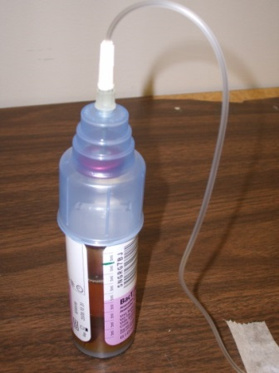

16. Allow the bottle to fill with 10ml of blood per bottle. (use the graduations on the side of the bottles as a guide)
For pediatric collection,
- Draw no more than 1% of the total weight
- Yellow pediatric bottles can hold up to 5ml of blood
17. Remove the first bottle(Aerobic-blue) and fill the next one (Anerobic-purple). After it has filled to appropriate level follow order of draw to draw any other bloods that may be ordered on that patient.

18. Gently invert all tubes with additive, 5-10 times to insure proper mixing.

19. Remove tourniquet.

20. Activate the needle safety device on the winged infusion needle immediately apply pressure with 2x2 gauze to stop bleeding and prevent bruising.
.
21. Tape gauze to puncture site.
23. Dispose of vacutainer/needle assembly in the Sharps Container; dispose of other waste in appropriate containers.
24. After blood specimen(s) is/are obtained, while at the bedside, label all tubes with patient information label; if a pre-printed label is not available, the hand written label must contain the patient’s name, date of birth, date and time of blood sample collection and initials of person drawing blood sample.

25. Insert blood tubes into specimen bag; close securely and send/tube to the lab

If a second set of blood cultures is required then repeat the procedure.
Never draw both sets from the same venipuncture site.
For best practice, draw each set from a different arm when possible.

Best Practice Recommendations for Blood Culture Collection:
- Collect via peripheral venipuncture - not central venous access devices (CVADs).
- Obtain at least 2 sets of paired blood cultures through peripheral venipuncture at different sites. Each set should be made up of two bottles aerobic and anaerobic.
- Drawing cultures directly into the bottles decreases contaminations rates and sharps exposure.
- There is no need to wait for specimen collection beyond the time needed for site preparation, regardless of whether or not the same site is accessed.
- If one site is used only one set can be drawn per venipuncture. Site must be re-prepped between venipunctures.

- Each blood culture set Clean tops of the bottles with the alcohol and allow drying completely. Use chlorhexidine to prep the patient’ site. Making sure to scrub the site for 1 minute allow to dry
- In adults 20 ml is the preferred volume (10 ml in each aerobic and anaerobic bottle).
- Pediatric patients should not use adult bottles if less than 5 ml of blood is obtained. No more than 1% of total body weight should be drawn.

REFERENCES: : Halm, M., Hickson, T., Stein, D., Tanner, M. & VandeGraf, S. (2011) Blood cultures and central line catheters: is the “easiest way” best practice? American Journal of Critical Care, 20(4).

