|  |  |
| --- | --- |
|  | **Effective Date:** 2-16 |
| **Title: Dermal Puncture Capillary Collection by Heel Stick** | |
| **Author: Kimberley Denovio Phlebotomy Manager SPHP Signature:** | |
| **Applies to:**  **The following SPHP Component Corporations:**  **St. Peter’s Hospital – Medical Director: Lisle Eaton M.D. ________________________________**  **Albany Memorial Hospital – Medical Director: Lisle Eaton M.D. __________________________**    **Samaritan Hospital – Medical Director: Dalia Eldeiry M.D. ______________________________**  **St. Mary’s Hospital – Medical Director: Dalia Eldeiry M.D. ______________________________**  **St. Peter’s Health Partners Medical Associates – Medical Director: Thomas Lawrence M.D.**    **______________________________** | |

Supersedes: : DocuShare/Laboratory/Laboratory Resource Manual/Blood Collection/Blood Collection by Heel Stick - Capillary

Location: DocuShare/Laboratory/Laboratory Resource Manual/Blood Collection/ Dermal Puncture Capillary Collection by Heel Stick

**PRINCIPLE:**

The heel is used for dermal punctures on infants less than 1 year of age because it contains more tissue than the finger, and has not yet become callused from walking.

**SPECIMEN:**

**PATIENT PREPARATION:**

1. CLSI Guidelines: In small premature infants, the heel bone (calcaneus) may be no more than 2.0 mm beneath the plantar heel skin surface and half this distance at the posterior curvature of the heel. Puncture depths for premature neonates should be between 0.65-0.85 mm. Larger infant puncture depths should be 1.0mm. Puncturing deeper than 2.0 mm on the plantar surface of the heel of small infants may risk bone damage.

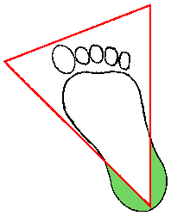*Medial &Lateral Plantar area*

1. Acceptable areas for heel puncture are shown in the figure above and are described as the medial and lateral areas of the plantar (bottom) surface of the heel. Notice that these areas can be determined by drawing imaginary lines extending back from the middle of the large toe and from between the forth and fifth toes. It is in these areas that the distance between the skin and the calcaneus (heel bone ) is the greatest.
2. Use warm pack to pre-warm heel for 3-5 minutes. This will increase blood flow to the area.
3. Hold foot firmly to prevent movement during the entire procedure.
4. Bandage newborns’ foot ONLY when necessary (due to sensitive skin).

**EQUIPMENT AND MATERIALS:**

* Specimen collection tubes and/or microtainers, capillary tubes or filter paper (PKU screening)

- Warm pack

- 2 x 2 sterile gauze pads - clean gloves

- sterile 2 mm automatic lancet device - small bandage

- 70 % isopropyl alcohol preps - biohazard specimen bag

- sharps container

**TEST PROCEDURE:**

1. Identify self to infant’s family member (if present) and explain procedure.

For inpatient, identify baby using name and DOB on hospital band.

1. Confirm patient identity in accordance to positive patient ID policy, using name and DOB.
2. Confirm test order and specimen requirements before beginning procedure. Assemble necessary materials.
3. Pre-warm infant’s foot for 3 – 5 minutes by using warm pack.
4. Wash hands and put on clean gloves.
5. Cleanse infant’s heel by scrubbing with alcohol prep for 1 min. Allow to air dry.
6. Hold foot firmly (do NOT re-contaminate site) and puncture the side of the heel (as in diagram) with automatic lancet device. Make puncture ACROSS heel print lines to enhance droplet formation.
7. Wipe away first drop of blood with sterile gauze to eliminate surface alcohol and tissue fluid contamination.
8. Gently squeeze and apply pressure to the foot. (Avoid excessive pressure or massaging.)
9. Apply drops of blood into or onto appropriate containers (refer to order of draw when collection multiply microcontainers) as required by ordered tests. Tubes containing anticoagulant should be capped and then gently inverted or tapped to mix properly. Do NOT shake violently.
10. When collection is finished, elevate heel and apply pressure with sterile gauze until bleeding stops. Bandage ONLY when necessary due to infants’ sensitive skin.
11. Label containers with patient name and DOB. Record date, time, and phlebotomist’s initials on requisition slip.
12. Place specimens in biohazard specimen bag.
13. Dispose of contaminated materials in appropriate containers. Lancets MUST be discarded in a sharps container.
14. Remove gloves and wash hands.
15. Deliver labeled specimens to laboratory in a timely manner.

**PROCEDURE NOTES:**

1. Blood Cultures must NOT be collected by heel stick or finger stick.
2. If bubbles are present when collection capillary blood in a micro collection tube. Bubbles in the tube can cause inadequate sample volume or exposure to air in the case of blood gases.
3. Specimens MUST be discarded and re-collected if: improperly labeled, unlabeled, hemolyzed, clotted (in anticoagulant) AND/OR exceeds testing time requirements.
4. Order of draw for the mircrocontainers: lavender then yellow/amber/red tubes.

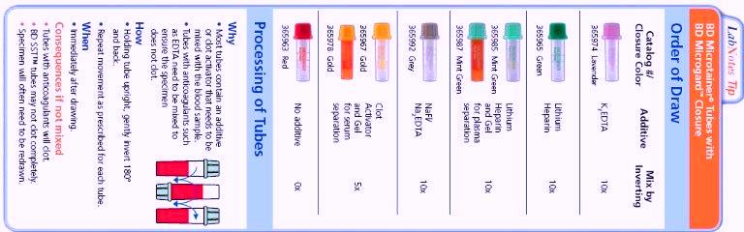

**REFERENCES:**

1. M.D. Anderson Hospital, Department of Clinical Chemistry and Laboratory

Medicine, Venipuncture Manual, 1974.

1. Microtainer Brand Tubes, Becton Dickinson, June 1997.
2. LSUMC, Clinical Laboratory Policy and Procedure Manual, [www.sh.lsuhsc.edu](http://www.sh.lsuhsc.edu).

Dec. 2005.

1. Clinical and Laboratory Standards Institute, Vol. 24, No. 21, June 20 2004.
2. Phlebotomy workbook for the multiskilled Healthcare Professional, Susan King Strasinger; Marjorie A. DoLorenzo Copyright 1996.