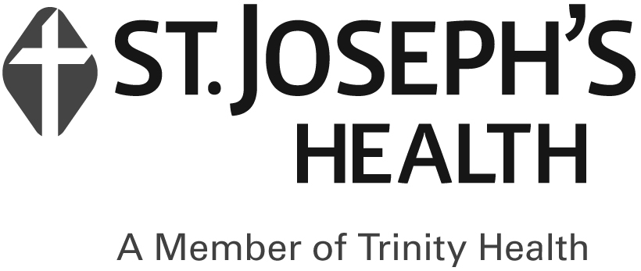
Community Health Connections Health Home

Billing Attestation Form
Staff Member Name: | ___________________________________
Care Management Agency: | ___________________________________
Billing Month: | ___________________________________

I, ______________________, or a designee from the Care Management Agency, have reviewed all billing and HML assessments and attest that:

☐ All Members identified as having a billable service for the month have a service that satisfies the CHC policies and procedures regarding billable services.

☐ All billable services provided to Members are documented in the Member’s electronic health record.

☐ Documentation supporting the responses to each Member’s HML was obtained and recorded in the individual’s electronic health record.

________________________________  Staff Signature | _________________  Date

